

CTCF (K344E)
Catalog Number: CR-M26324
Gene Symbol: CTCF; MRD21
Description: Anti-CTCF (K344E) Mouse Monoclonal Antibody

Background: Transcriptional repressor CTCF also known as 11-zinc finger
protein or CCCTC-binding factor is
atranscription factor that in humans is encoded by the CTCF gene. CTCF is involved in many cellular processes, including transcriptional
regulation, insulator activity, recombination and regulation of chromatin architecture.
Immunogen: A synthetic peptide from the internal region of CTCF which includes the mutation ofK344E, human origin.
Tested applications: ELISA, WB, IHC Recommended dilutions:
ELISA: 1:1000-1:5000
WB: 1:500-1:1000
IHC: 1:50-1:100
Concentration: 1 mg/ml
Host: Mouse
Clonality: Monoclonal
Purity: Purified from ascites
Format: Liquid Storage buffer:
Preservative: no
Constituents: PBS (without Mg2+ and Ca2+), pH 7.4, 150 mM NaCl, 50% glycerol
Species Reactivity: Recognizes K344E mutant, but not wild-type CTCF of vertebrates.
Storage Conditions: Store at -20°C. Avoid freeze / thaw cycles.

Western blot:
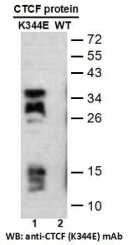
Western blot analysis of recombinant CTCF (K344E) and wild-type proteins.
Purified His-tagged CTCF (K344E) protein (lane 1) and corresponding wild-type protein (lane 2) were blotted with anti-CTCF (K344E)
monoclonal antibody (Cat. #26324).

For research use only. Not for diagnostic or therapeutic applications.

Immunofluorescence:
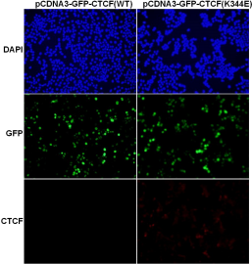
Immunofluorescence of cells expressing CTCF proteins with anti-CTCF (K344E) antibody.
HEK293T cells were transfected with
pCDNA3-GFP-CTCF (WT) plasmid (left column) or pCDNA3-GFP-CTCF (K344E) plasmid (right
column), then fixed and stained with
anti-CTCF (K344E) monoclonal antibody (Cat.
#26324).

科博瑞（武汉）生物科技有限公司
TEL：027-87615885 15972062685
- mail：3636901710@qq.com
Web:www.coburybio.com

